**Estimating Bioenergy Feedstock Water Footprints Using a Database and System Dynamics Approach**

*Daniel Inman, Ethan Warner[1], Dana Stright, Jordan Macknick, Corey Peck*

Abstract (245/250 words):

Increased biofuel production has prompted concerns about the environmental tradeoffs of biofuels compared to petroleum-based fuels. Biofuel production, in general, and feedstock production, in particular, is under increased scrutiny. Societal scrutiny derives from fear of depleting rural water supplies through activities such as irrigation for large-scale agricultural production. Water footprinting has been proposed as a possible clear and comprehensive measure to evaluate water use with regards to these concerns

Existing water footprinting literature examining these concerns has often been limited in several key aspects. Key limitations include complete assessments across multiple water stocks (e.g., vadose zone, surface, and ground water stocks), geographical resolution of water footprinting data, representation of many agricultural feedstocks, and flexibility to perform scenario analysis. We developed a model called BioSpatial H2O to address some of these limitations.

BioSpatial H2O uses the Penman-Monteith approach to calculate a complete water footprint. BioSpatial H2O is unique in its links to a database composed of annual spatial explicit climate, soil, and plant physiological data used to estimate annual crop water requirements. In this paper we present the modeling approach and illustrative results using corn grain and soybeans as examples of current biofuel crops. Estimated green water footprints are comparable to other modeled results, suggesting Spatial H2O is computationally sound. The database includes other crop categories such as perennial grasses and could also be modified to represent alternative climatic conditions. Scenario analysis examining the implication of expanding cellulosic biofuels is a unique feature of BioSpatial H2O.

Keywords: water footprinting, agriculture, green water, blue water, biomass, bioenergy, sustainability

Main Paper (~5000):

**1. INTRODUCTION**

*1.1. Water Scarcity*

Water is a limited resource and agriculture is the main consumer globally.(1) Agricultural water consumption has the potential to become an even more contentious issue in the future due to expansion of biofuels. Production of food, feed, and fiber consumes about 86% of the global freshwater use.(2) Water used for agriculture makes up more than 90% of water withdrawals in some developing countries.(1) Consequently, agriculture is in conflict with other users of fresh water such as municipalities and industry in many parts of the world.(3) Balancing the competing uses for a limited water supply is contentious and can have significant societal and environmental impacts. For example, aquatic environments show signs of decline and degradation due in part to how water is managed in many nations.(4) Balancing the many uses for water while still meeting basic human needs will be challenging in the coming decades.(5, 6) If water becomes more scarce, diverting surface and ground water without negatively impacting the environment will become challenging.(4)

Population growth and climate change are already stressing some water-scarce regions of the world.(7) In 2005, it was estimated that about 35% of the world population experienced long-term water shortages.(8) United Nations Educational, Scientific and Cultural Organization (UNESCO) estimates that water shortages are already a constraint on economic growth in India, China, and Australia.(1) Projections by United Nations Environment Program (UNEP)(9) suggest that by 2025, most of the global population will live in areas with periodic water shortages. Concerns over whether the food, feed, and fiber needs in the future can be met in regions with limited water resources are substantial(4, 10-13) given projections of a world population of 9.6 billion people by 2050.(14)

In the United States, which serves as the geographic focus of this study, agricultural areas experience periodic drought conditions. In 2013, states such as Minnesota, Kansas, and Nebraska underwent moderate to extreme drought conditions.(15) Simultaneously, as climates change, Kenneth et al. (16) project that frequency of droughts will increase in parts of some U.S. regions such as the southwest, the Rocky Mountain states, and the plains states.

*1.2. Water Footprinting Definition*

Our analysis uses the following definition of water use from the U.S. Geological Survey (co.water.usgs.gov/infodata/wateruseconcepts.html):

“Water use in the broadest sense,[sic] pertains to the interaction of human activity with and its influence on the hydrologic cycle and includes elements such as self-supplied withdrawal, public-supply delivery, consumptive use, wastewater release, reclaimed wastewater, return flow, and instream use. In a restrictive sense, water use refers to water that is actually used for a specific purpose, such as for domestic use, irrigation, or industrial processing.”

“Offstream water use occurs when water is withdrawn or diverted from a ground- or surface-water source for public-water supply, industry, irrigation, livestock, cooling for thermoelectric power generation, mining and domestic purposes.”

“Instream water use occurs when the water remains in the stream (surface water) or aquifer (ground water) during use.”

Water footprinting characterizes total water consumption along with the sources of the water consumed.(17) Therefore, we consider both “green” and “blue” water consumption in this paper. Our definition of green water and blue water are in agreement with other literature such as Yeh et al.(18) and Hoff et al.(19) Rockström et al.(20) describing these concepts:

“… green water is the soil water held in the vadose zone, formed by precipitation and available to plants, while blue water refers to liquid water in rivers, lakes, wetlands and aquifers, which can be withdrawn for irrigation and other human uses. Consistent with this definition, irrigated agriculture receives blue water (from irrigation) as well as green water (from precipitation), while rain-fed agriculture only receives green water. Rainwater harvesting is at the interface of blue and green water. Catching runoff and storing it in small reservoirs (or possibly underground) is interpreted as blue water management; enhancement of infiltration and storage of rain in soil as green water management (pg. 178).”

Blue water withdrawn from aquifers (outstream) and surface water (instream) can be consumed or released as a part of its utilization. Instream use removes water through incorporation into the crop, evaporation, and evapotranspiration. Outstream use is water released into the environment without quality changes and therefore can be used elsewhere for agriculture, industry, and drinking water. Green water by definitions is rainwater that is consumed.

In our study we specifically differentiate “full growth” water consumption for a given climate and crop production from “actual” water consumption. Actual water consumption represents what a farmer applied and what is used by an agricultural crop. Actual water consumption may be lower than “full growth” water consumption depending on the individual producer’s risk tolerance (i.e., yield reduction because of reduced water).(21) For example, farmers may deliberately not irrigate if local water resources are restricted (e.g., by physical availability, lack of irrigation infrastructure, or by public policy) or market conditions are such that irrigation is not cost-effective. Water consumption and its effects have been measured differently across studies.(18) Literature focused on total water consumption is mostly based on evaluating self-reported blue water use combined with green water use estimates.

*1.3. Existing Water Footprinting Studies*

Production of crop-based transportation fuel has been reported to consume more water than fossil energy production per unit of fuel produced.(22, 23) Bioenergy systems consume water all along the supply chain, but the major uses of water occur in the cultivation of the biomass-feedstock and biomass-conversion-to-fuel phases of bioenergy production.(23) This study focuses on agricultural biomass production. In feedstock cultivation, water is typically lost to the atmosphere through evapotranspiration during the growth cycle of cultivated feedstock.

Recent studies indicate that considerable improvements can be made in efficiency of water consumption in the production of agriculture and, specifically, bioenergy crops.(22, 24-26) For instance, perennial energy crops could reduce overall water use if grown on extensively managed land, such as arable fields used intermittently as pasture for grazing animals.(27) Studies have also suggested that perennial crops may improve soil water retention and lower soil evaporation relative to annual crops, depending on location and climate, while redirecting unproductive water evaporation and runoff .(26, 28)

Bioenergy systems can use a range of agricultural, industry, and forestry related wastes and residues that have little to no direct claims on water consumption and are higher yielding feedstocks.(28) Removal of wastes and residues may have implications for the hydrological cycle, but their impacts depend on the prior use of the waste or residue (e.g., left in field or sent to land fill). For example, annual cropping systems that leave residues on the ground could provide soil water retention benefits. Another opportunity to improve the efficiency of water consumption is the use of land types unavailable for typical agricultural production (e.g., unirrigated, degraded, or marginal lands). On these lands, the use of a lignocellulosic crop would improve soil water retention.(28)

*1.4. Bioenergy and Water Scarcity*

Understanding the spatial implications of water consumption from multiple bioenergy feedstocks is important for determining the impacts that expansionary bioenergy policy has on water resources. As water is diverted to production of bioenergy feedstocks, the water availability for food, feed, and fiber production could decrease.(29, 30) Greater biomass production may increase competition for water in critical areas.(23) For example, Berndes(31) reports that a large-scale expansion of bioenergy systems would lead to increased water use, through evapotranspiration, that is potentially as large as existing water consumption from agricultural land.

Water availability may already impose barriers on the future expansion of bioenergy in a way that does not conflict existing agricultural food, feed, and fiber production. In the Berndes(26) study, some countries (e.g., the United States) are not currently facing major water constraints, but are projected to use more than 25% of available surface and ground water reserves by 2075.(26)Many countries such as South Africa, China, and India are already facing water scarcity issues that constrain large-scale bioenergy production.(26) In the future, climate change and population growth may exacerbate these limitations; increasing the utilization efficiency of existing water resources may reduce the risk of conflicting with other uses.(27)

**2. REVIEW OF CURRENT WATER CONSUMPTION MODELS AND ASSESSMENT METHODS**

*2.1. Penman-Monteith Method*

The Food and Agriculture Organization’s (FAO) Penman–Monteith method(21) is an established crop evapotranspiration model using plant physiology, soil data, and climate data to calculate irrigation requirements.(21) Many studies (e.g., Gerbens-Leenes et al.(32) and Hoekstra et al.(33)) use forms of this method to calculate crop water footprints. The Penman–Monteith method estimates evapotranspiration as shown in the equation below.

Eq. 1

ETc is total evapotranspiration (mm day−1) from a crop or “c”. Kc, a crop coefficient, accounts for plant characteristics, such as albedo and crop height, that distinguish a crop from the reference surface. Kc represents a crop based constant that varies from 0 to 1. ETo represents the reference crop evapotranspiration (mm day−1). The ETo characterizes climate effects and is based on a calculation using temperature, solar radiation, wind speed, and relative humidity as shown in the equation below.

* Δ = slope of the vapor pressure curve (kPa ◦C-1)
* T = average air temperature (◦C)
* γ = psychrometric constant (kPa ◦C-1)
* es = saturation vapor pressure (kPa)
* ea = actual vapor pressure (kPa)
* Rn = net radiation at the crop surface (MJ-day m-2 )
* G = soil heat flux (MJ-day m-2)
* u2 = wind speed at 2 m (m s-1).

*2.2. Public Modeling Systems*

There are several publically available modeling systems based on the Penman-Monteith method.(21) FAO’s CROPWAT model(34) formulizes the Penman-Monteith method into a model in which users can input data to the equation to calculate crop water requirements and irrigation requirements based on soil, climate, and crop physiological data. CROPWAT is a platform for calculations and does not contain its own datasets. FAO offers sources of climatic data, such as CLIMWAT,(35) which includes more than 5,000 stations globally.

A model closely related to CROPWAT, the Water Footprint Assessment model (<http://www.waterfootprint.org/tool/home/>, Water Footprinting Network) uses CROPWAT structure and global climatic, soil, and plant physiological data to evaluate aggregate water consumption. The Water Footprint Assessment model provides water footprints (including blue and green water consumption) of multiple agricultural crops and industrial and drinking water sectors on a global, country, or water basin level. Higher resolution estimates of water consumption are not currently available.

Similar to the Water Footprint Assessment model is the Consumptive Use Program+ (CUP+)(36). CUP+ estimates crop water requirements and irrigation requirements based on soil, climate, and crop physiological data with geographic coverage limited to the state of California. The application has the capacity to study the impact of climate change on water requirements and irrigation water needs. Unlike CROPWAT, CUP+ contains initial climate, soil, and plant physiological data for assessment, and unlike the Water Footprinting Assessment model, CUP+’s assumptions (e.g., wind speed and average temperature) can be modified by the user.

Several existing tools/databases exist for assessing other aspects of water use such as water erosion of soil (e.g., are available WEPP(37)) and water flows in and out of soil (e.g., DAYCENT/CENTURY(38)), but do not estimate water consumption.

*2.3. Modeling and Assessment Strengths and Weaknesses*

Recent publications on bioenergy water use have raised awareness of the potential for increasing agricultural water consumption for bioenergy production to impact other uses of water (e.g., other agricultural uses, industry, and municipal) and the environment.(28, 31, 33, 39, 40) The existing literature exhibits differences in scope, system boundaries, definitions, and methods, which hampers drawing sufficient understanding of the water impact of bioenergy water use.(41) With regards to the U.S., existing literature generally provide data to make broad comparisons across current common biofuel feedstocks at the state and sometime the county level.(39, 42-44)

Decision-making based on most current literature is difficult for two reasons. Water impacts of biofuel systems are potentially highly variable and often determined within the local contexts related to factors such as water availability, the interactions of land and water, and climate for a particular time frame.(41) Decision-making is often focused on planning or examining the potential impacts of decisions or potential decisions on the future rather than on only existing systems.

Many of the initial water footprinting studies only account for water that is applied through irrigation (i.e., blue water).(22, 45, 46) Irrigation is a major use of water, but about 80% of global agriculture production and 85% of the major U.S. biofuel feedstock, corn grain, is exclusively rain-fed (i.e., green water).(22, 47) Analyses that only account for blue water overlook a large portion of the overall water consumption from rain water. Also, green water consumption, if not allocated to crop production or other uses, can influence the availability of blue water.(23) For example, increases in the green water footprint can increase the time needed for aquifers to recharge their water storages.

Bioenergy systems are complex and highly variable because of the numerous possible feedstocks that can be utilized and end uses that are available. Figure 1 presents a generalized outline of many bioenergy production systems. Currently, bioheat and biopower are typically produced from lignocellulosic crops and biofuels from oil, sugar, and starch crops. Each of the feedstock choices illustrated in Figure 1 has a different water requirement, both in terms of a crop’s physiological water needs and in terms of where a crop is typically grown. The choice of feedstock has a significant impact on the overall water consumption related to a given bioenergy pathway.

The diversity in bioenergy feedstocks has important implications with regards to managing water resources. Making choices between feedstocks that could achieve similar ends (e.g., policy requirements) but have different implications for water consumption necessitates the ability to evaluate and compare them. Many existing water consumption studies have been limited in the scope of crops evaluated, and thus inhibit multi-crop comparisons.



**Figure 1.** Pathways of agricultural feedstock to energy, food, feed and fiber uses.

Most recent studies that model blue and green water footprints lack high spatial resolution. Oftentimes, results are aggregated to a global, national, or U.S. state-level average. Only recently have publications on county level water footprints been published.(42) Aggregate results can be misleading and give the impression that water consumption is consistent over the evaluated geographic area. Variability in water consumption is impacted by a myriad of interacting factors such as local climate, soil characteristics, crop management practices, and plant philological parameters, to name a few; see Allen et al.(21) for a detailed description of the factors that influence crop water consumption.

No spatially explicit modeling efforts consider alternative non-historic conditions (e.g., climate change) that might impact future bioenergy water consumption was found. Exploring alternative future conditions is particularly important for understanding the potential future effects of selecting among multiple crop options and water use management practices for bioenergy feedstocks.

**3. DATABASE FRAMEWORK AND SYSTEM DYNAMICS APPROACH**

Our water footprinting tool, BioSpatial H2O, is a novel modeling approach for evaluating water footprints. BioSpatial H2O improves on existing analysis by addressing several limitations of existing agricultural crop water consumption assessments outlined in previous sections and allowing for potential modification to address other limitations. The model is designed to estimate green water consumption based on climatic and soil data and as well as “full growth” potential blue water consumption based on remaining physiological requirements of a crop. BioSpatial H2O allows for water footprinting at specific climate stations (i.e., our lowest resolution datasets). BioSpatial H2O can evaluate a diversity of U.S. agricultural feedstocks including most of those shown in Figure 1 including several we could not find water footprinting literature on. Finally, BioSpatial H2O is a flexible platform for scenario analysis and adoption to other conditions such as climates and geographic locations. BioSpatial H2O is mostly limited by the datasets and data resolution that is available.

*3.1. Model Overview*

Complex systems, such as those related to the environment, often exhibit unexpectedly rapid or sluggish changes in response to conditions such as changing climate, technology, socio-economics, and public policy. (48) Forethought to anticipate unintended consequences and understanding the dynamics of a system that prevent change is necessary for effective decision making about risk management. For example, decision-making about cellulosic biofuel feedstock research may seek to minimize the risk of water competition with current agricultural uses of water. An understanding of alternative cellulosic feedstock water requirements under different climatic conditions in alternative regions could aid the decision-making process.

BioSpatial H2O uses a SD modeling framework that is underpinned by a high spatiotemporal climate and soils dataset;(49, 50) the model has been developed in STELLA.(51) SD is an approach for framing, discussing, and understanding the behavior of complex systems over time. It uses internal feedback loops, stocks and flows, and time delays to model this behavior. SD models can be powerful tools for generating and communicating important insights about complex systems to the public,(52) and SD has long been used to examine and inform a wide variety of public policy questions and applications.(53)

Figure 2 illustrates BioSpatial H2O’s generalized data process. BioSpatial H2O consists of four main components: the database framework for managing data, the STELLA model, a Visual Basic for applications automation script, and visualization of results. Our model uses climate and soil data inputs from Cligen and STATSGO2 to calculate the water footprinting, using a daily time step for 2,648 stations across the United States. More detailed model documentation can be found via the Bioenergy Knowledge Discovery Framework or Github.

*3.2. Overview of Data Sources, Processing, and Management*

BioSpatial H2O is currently based on available agricultural crop data from STATSGO2 and climate data from Cligen,(49) but soil and climate datasets from other sources can be substituted. BioSpatial H2O evaluates a “full growth” potential water footprint and does not evaluate actual water consumption because the social and economic drivers of such decisions would be difficult to model for any particular location at a given point in time.

BioSpatial H2O uses Cligen(50) for climatic conditions. We automated the Cligen simulation to produce 30 years of daily climate data for 2,648 stations across the United States. The number of Cligen stations provides rich spatial coverage for spatial analysis such as creating surface datasets. Cligen is a stochastic climate data simulator that generates daily estimates for parameters such as precipitation (mm day-1), temperature (degrees Fahrenheit), dew point (degrees Fahrenheit), wind (km day-1), and solar radiation (MJ-day meters-2). It uses monthly parameters (e.g., mean, standard deviation, and skew) derived from historic measurements to create daily climate estimates. The database frameworks extracted, loaded, and transformed the raw data output from the SD model simulation. Using database query language, exogenous climate model inputs are generated by calculating averages of Cligen daily data by month for precipitation, temperature, dew point, and wind speed. The model inputs contain 365 daily data points for each of the 2,648 stations for each metric.

STATSGO2 provides data(49) for soil conditions. It is a generalized 1:250,000 resolution soil dataset. STATSGO2 data metrics are queried based on the National Resources Conservation Service soil mapping units and spatially joined to the Cligen station locations. The database framework extracts soil metrics for each Cligen soil mapping unit, and the weighted average for unit is based on horizon thickness for the depth reported. STATSGO2 soil input parameters used in BioSpatial H2O include available water capacity (mm day-1), which we calculated from soil physical properties and crop yields (Mg ha-1). As a default, we used the non-irrigated STATSGO2 crop yields and aggregated each crop type the following categories: perennial forage, annual forage, corn grain, feed crop, fiber crop, spring grains, oil crop, sugar crop, winter grain, and soybeans. It should be emphasized that the model can accept yield data from any source that reports in SI units.

BioSpatial H2O uses crop planting and harvesting data from the U.S. Department of Agriculture (USDA) National Agricultural Statistics Service(54, 55) and joins the planting and harvesting dates to the Cligen locations and STATSGO2 mapping units by crop type, and used those as exogenous inputs for calculating the crop coefficients (see section 3.3 below).. The database framework calculates an average planting and harvesting date across multiple crops to represent aggregate biofuel crop categories within the model.

While improvements on existing research, BioSpatial H2O datasets are limited in several key respects. The datasets available for operating BioSpatial H2O limit the ability to model crops in regions where they are grown, but no data is available because they are grown intermittently. Another issue is that Cligen climate data are based on a location sampling driven by available stations. This contrasts with STATSGO2 data, which are relatively high resolution and completely cover most of the continental United States. Cligen station coverage of the United States is relatively complete (i.e., a dozen stations in each state), but that does not preclude bias introduced by the number of stations available over a geographic area. County, state, and national estimates might be biased by the station sampling of the local climate if coverage is low or clustered in a particular area. Harvest and planting date data is also not as complete as available Cligen stations, so the actual stations in use for each crop category will vary by feedstock. Finally, the climate and soil data management system is more complex than the SD model described and next section and would not be as easily modified by users inexperienced in database management and model automation.

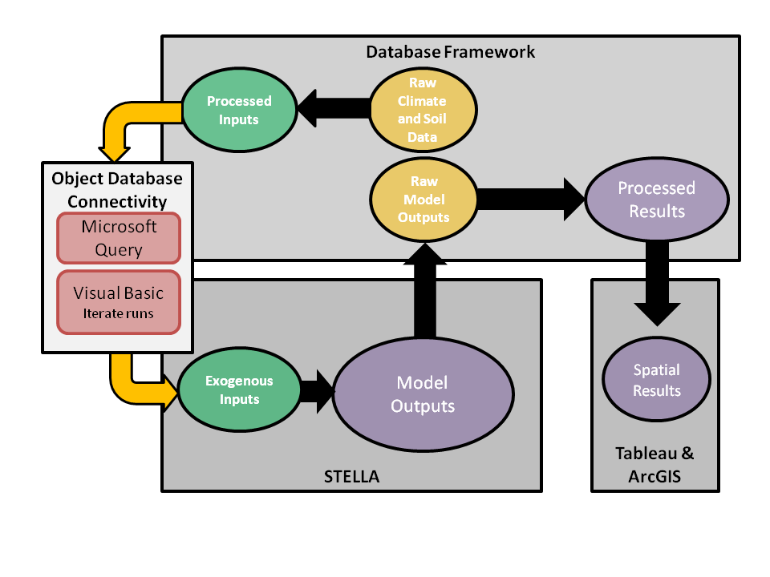**Figure 2.** Water footprinting model, data processing, and management diagram.

*3.3. Overview of the SD Model*

The Penman-Monteith method equations(21) and the SD model they reside in are simple parsimonious and readily modifiable by users. Figure 3 illustrates the generalized influence diagram of the SD model for estimating green and blue water consumption. Blue water consumption (M3 Mg-1) of agricultural feedstock is estimated using yields and crop evapotranspiration rates. It should be noted that the blue water foot print, as calculated in this model, is affected by an assumed tolerance to crop yield loss. For purposes of illustration, we have assumed this parameter to be zero; in other words we assume that there is no tolerance to yield reduction and thus the blue water values reported should be viewed as maxima. In practice, however, there will be some level of tolerance to yield loss. As opposed to a yield maximizing model, which is our default case, the model could be easily modified to be water maximizing with the appropriate data. Green water (M3 Mg-1) is determined by the available soil water and crop evapotranspiration rates. Available soil water is constrained as determined by average precipitation and soil texture. Crop evapotranspiration is calculated based on an evapotranspiration reference surface and an endogenous or exogenous (user-defined) crop coefficient. For the endogenous crop coefficient calculation, the model uses the single crop coefficient approach as outlined in Chapter 6 of FAO paper number 56 (Add reference here).

The SD model calculates green and blue water consumption for aggregate agricultural crops where STATSGO2 data are available. Default BioSpatial H2O outputs include blue and green water for the following aggregated crop categories: perennial forage, annual forage, corn grain, feed crop, fiber crop, spring grains, oil crop, sugar crop, winter grains and soybeans; additional aggregations of STATSGO2 crops are also possible. Equations in the STELLA model are based on FAO’s Penman-Monteith method,(21) which are modifiedfrom Allen (1998).(21) , and are solved daily.



**Figure 3.** SD model overview diagram.

*3.5. Model Verification*

BioSpatial H2O results have been validated against available literature. Below we compared green and blue water footprinting results to existing county-level and higher resolution water consumption assessments.(23, 32, 43, 44, 56, 57) Ideally, BioSpatial H2O’s results would be compared to site-specific cases, as represented in the Cligen data used for calculations. However, as outlined in Section 1.3, options for high geographic resolution water consumption assessment are limited.

**4. WATER FOOTPRINTING RESULTS**

*4.1. Discussion of Illustrative Results and Comparison to Other Studies*

BioSpatial H2O blue and green water footprints for corn grain and soybeans, by Cligen station, are shown in Figures 4 and 5. As expected, blue and green water footprints for both crops are greater in the western United States. Overall water footprint trends for corn grain and soybeans are commensurate with those in the literature (e.g., Chiu et al.(42), Gerbens-Leenes et al.(32), and Dominguez-Faus et al.(43)). For example, overall water requirements generally increase when moving into hotter and/or drier climates.

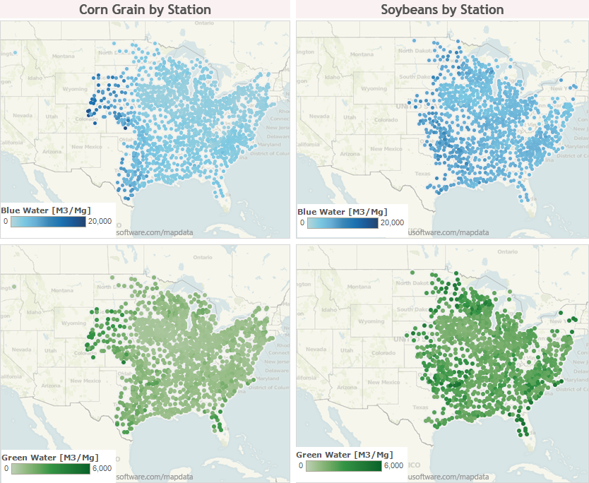

**Figure 4.** BioSpatial H2O corn grain and soybean station coverage for green and blue water consumptions.

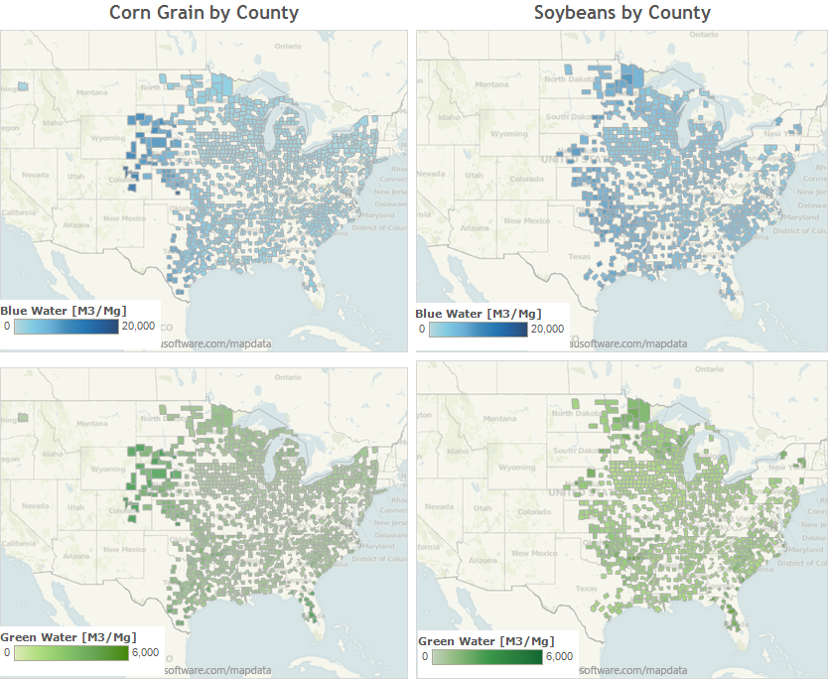

**Figure 5.** BioSpatial H2O corn grain and soybean county-level coverage for green and blue water consumptions.

Plots of blue and green water variance, by state, for both corn and soybeans are shown in Figure 6. Overall, the estimates for corn and soybean green water footprints compare well with those in the literature. Literature water footprints generally range from 100 to 1,200 m3 Mg-1 of corn feedstock for corn-producing states such as Iowa, Minnesota, Illinois, and Nebraska.(42, 44, 57) While soybeans are not as thoroughly studied, Chiu et al.(42) estimates green water footprints ranges from around 1,000-4,000 m3 Mg-1 soybean feedstock by county for soybean-producing states such as Iowa, Minnesota, Illinois, and Nebraska. The BioSpatial H2O green water footprint medians for typical agricultural states range from 400-2,000 m3 Mg-1 for corn grain and 1,700-3,300 m3 Mg-1 for soybeans. Estimates that are on the extreme ends of the ranges are likely a result of localized variability that would not be captured in the state and county averages of other analyses. State-level results from BioSpatial H2O compare well with other published analyses. (42, 44, 57) As expected, results from BioSpatial H2O show that states such as Iowa, Minnesota, Wisconsin, and Illinois have higher green water footprints than drier states like Nebraska, Colorado, and Kansas.

Estimates of the blue water footprint from BioSpatial H2O are generally higher than those from other water footprint models. In BioSpatial H2O, the blue water footprint is estimated without any assumptions regarding an individual producer’s tolerance to risk (i.e., loss in expected crop yields). The Penman-Monteith framework, as applied in BioSpatial H2O, calculates the blue water footprint as the difference between the crop’s physiological requirement for water and what is supplied by soil water (i.e., green water). Therefore, blue water results from BioSpatial H2O should be viewed as the “theoretical” and/or “maximum” blue water footprint. Although BioSpatial H2O uses a calculation framework (i.e., Penman-Monteith) that was intended to develop irrigation schedules for individual fields, BioSpatial H2O is not an irrigation planning tool and thus does not make assumptions regarding producer- and field-level management decisions.

Other studies use irrigation withdrawals as reported by crop producers as their blue water footprint. These estimates range from 0-550 m3 Mg-1 for corn grain and 0-1,300 m3 Mg-1 for soybeans for the major corn and soybean producing states.(23, 32, 43, 44, 56, 57) Our blue water footprint ranges from 1,500-7,000 m3 Mg-1 for corn grain and 3,500-9,000 m3 Mg-1 for soybeans in major corn grain producing states. Because BioSpatial H2O uses theoretical calculations of blue water based on the plant physiology and the immediate soil and climate conditions, crops that are not produced at a commercial scale and/or crops that are not traditionally irrigated may be assessed for their potential blue water footprint in a given area. For example, BioSpatial H2O is well suited to perform scenario analysis of different cropping arrangements in areas that are on the frontier of feedstock production.

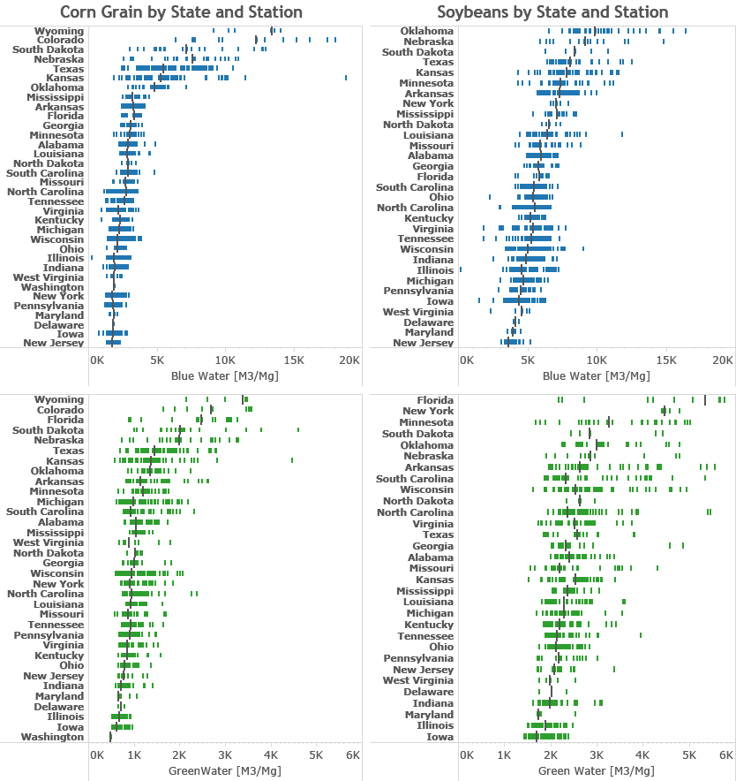

**Figure 6.** Corn grain and soybean green and blue water consumption by state.

*4.2. Water Footprinting Tool Flexibility and Improvements to Scenario Analysis*

BioSpatial H2O builds on previous water consumption analyses to provide a platform for more a complete assessment scenario based assessment, which can better inform decision makers about the potential impacts of decisions. Although we have only shown results for corn grain and soybeans in this study, BioSpatial H2O models green and blue water footprints from multiple agricultural crops at a couple levels of geographic aggregations in the continental U.S. and allows for comparison among those options. For example, the water footprints of perennial grasses in Iowa could be evaluated and compared to other data such as yields or environmental impacts like GHG emissions.

BioSpatial H2O’s framework is flexible enough to be adapted for scenario analysis outside of U.S. crops grown in current climatic conditions. The model could be adapted for scenario analysis of alternative crop categories, locations where those crops are grown, and under alternative climatic conditions if the data is available. For example, BioSpatial H2O could be adapted to run scenarios looking at the water footprints of feedstock overtime as research and development (R&D) improves yields, drought tolerance, and other physiological factors. Future climate data (e.g., regression of Cligen data) to estimate the potential future crop water footprints could also be included. The results of such an analysis would help identify areas of risks associated with water use competition in particular regions among feedstocks and identify (R&D) pathways that increase or decrease the risk of water use competition.

BioSpatial H2O can be used to evaluate other geographic contexts at multiple spatial levels. Results from Section 4 demonstrate the capability to evaluate county, state, and national U.S. water consumption for commonly studied biofuel crops relative to some existing water consumption analysis. Evaluation of water consumption at multiple geographic levels can be important in evaluating the potential impacts of existing state and national bioenergy policies (e.g., US EPA(58) and EU(59)) and how those policies might interact. There are potential opportunities to analyze new policies or provide upper or lower bounds in sustainability certification of bioenergy projects. In addition to geographic assessment at multiple levels, BioSpatial H2O also has the potential to be adapted for analysis of water consumption of less researched regions (e.g., developing countries) of the world. BioSpatial H2O’s database could be modified for other geographic contexts where climate and soil data for running the model are available.

BioSpatial H2O was used in this paper to look at two common biofuel feedstocks, but the model has the potential for broader applicability. Besides the ability to assess optimal water consumption of potential crops for biopower, BioSpatial H2O can assess a wide array of agricultural commodities. As noted in Section 1.4, non-energy crops could be evaluated using BioSpatial H2O and therefore could be used as an input into decision-making in food and fiber sectors. The current version of BioSpatial H2O is designed to evaluate water consumption in agriculture crops. There is potential to adapt the database and SD framework to evaluate the water consumption of other energy technologies or water consumption in biomass conversion to fuel, heat, or power.

It is important to be able to estimate the potential water consumption of biofuel feedstocks in the future given expected climatic and demographic changes effecting water resources that are noted in Section 1.1. BioSpatial H2O’s dynamic capabilities and adjustable climatic data allow analysis of water consumption changes over time. For example, scenario analysis of alternative future policies such as the Renewable Fuel Standard 2(58) and proposed revision or policies supporting particular biomass feedstock (e.g., crops versus residues) could be examined in the context of alternative future climatic conditions.. BioSpatial H2O can be changed to represent alternative climatic conditions, assuming the availability of data for a given geographic area. These alterations can represent the potential impacts of climate change and allow for better assessment of the water consumption impact of a bioenergy policies in future years.

The SD framework provides a flexible and user-friendly interface for on-demand spatially explicit water consumption analysis for many U.S. agricultural crops. Expansion or modification of BioSpatial H2O to new conditions and applications would take time, but are also a possible use of the model. The user interface of the SD model component can be modified to allow BioSpatial H2O users access to different aspects of the water consumption calculations. These controls permit users to quickly make modifications and see the implications of those results in real time.

One example is the opportunity to run scenarios in a top down analysis of the theoretical blue water footprint compared to self-reported irrigation from the USDA.(60) This yield loss tolerance factor could be modified by state, county, or even station level to represent irrigation constraints and farmer’s choices with regards to irrigation. A potential analysis would include comparing actual yields to potential yields for a defined area, calculating the blue water footprint based on a yield loss tolerance factor reflecting actual yields, and comparing the blue water footprint to self-reported irrigation from the USDA.(60)

**5. SUMMARY**

Our review of water consumption analysis literature revealed several limitations in existing water footprinting assessments. Water consumption analyses often estimate aggregate water consumption from multiple sources, aggregate to national and geographic levels, cover a limited set of agricultural feedstocks, and lack flexibility to alter input assumptions. These limitations present a barrier to a more robust understanding of bioenergy water consumption, which is necessary for decision makers to evaluate the tradeoffs between bioenergy systems, other sources of energy, and other agricultural commodities.

To help address these limitations, we developed BioSpatial H2O based on a database framework that provides climate and soil data to an SD model and catalogues the results. Using Cligen and STATSGO2 datasets, BioSpatial H2O’s results and capabilities are demonstrated by comparing corn grain, and soybean case studies to other datasets and literature. Our evaluation of corn grain and soybean crops shows coverage of green and blue water consumption across major agricultural areas. BioSpatial H2O’s water footprints for those areas are comparable to existing water footprinting research, albeit with greater variability owing to the use of station-level rather than county- or state-level data. BioSpatial H2O’s coverage was not as extensive as reported water consumption due to the lack of spatially explicit data for many states west of the Rocky Mountains. The tool is limited in several key respects by the resolution of available data, and the complexity of data management could be a barrier to use. However, the results are comparable to previous analyses of optimal water consumption.

BioSpatial H2O improves on optimal water consumption analysis in several key respects. It allows for reporting at several geographic levels disaggregated over multiple water sources over time. The tool can also evaluate many agricultural feedstocks used for bioenergy, food, feed, and food in current and potential future use. Finally, the model and database structure could be a adapted to evaluate other energy technologies with relatively high water consumption impacts such as biopower and solar.(61) Potential future analyses with the BioSpatial H2O include estimating water footprints for alternative climate change scenarios, looking at water footprints of understudied countries where climate data are available, and examining water tradeoffs of alternative cellulosic feedstocks for biofuels in multiple U.S. locations.

ACKNOWLEDGEMENTS

This work was supported by the Office of Electricity Delivery and Energy Reliability. To our knowledge, the authors do not have any other potential conflicts of interest. Daniel Inman contributed to project scoping, major contributions to model development, and major contributions to the writing of the paper. Ethan Warner provided major contributions to the writing of the paper. Dana Stright provided major contributions to the STATSGO2 and CLIGEN database framework and minor writing contributions. Jordan Macknick provided major contributions to project scoping and minor contributions to writing. Corey Peck provided minor contributions to model and database framework development. Thanks Emily Newes, Margaret Mann, and (REVIEWERS TO BE ADDED).

7. References

1. UNESCO. *The United Nations World Water Development Report 3: Water in a Changing World*. Paris and London: UNESCO and Earthscan (2009).

2. Hoekstra AY, Chapagain AK. Water footprints of nations: Water use by people as a function of their consumption pattern. *Water Resources Management*. (2007);**21**(1):35-48.

3. Falkenmark M. Comparative hydrology—a new concept. In: Falkenmark M, Chapman T, editors. *Comparative Hydrology An Ecological Approach to Land and Water Resources*. Unesco, Paris, France(1989). p. 10-42.

4. Postel SL. Entering an Era of Water Scarcity: The Challenges Ahead. *Ecological Applications*. (2000);**10**(4):941-8.

5. Postel SL, Daily GC, Ehrlich PR. Human Appropriation of Renewable Fresh Water. *Science*. (1996);**271**(5250):785-8.

6. Gleick PH. The human right to water. *Water Policy*. (1998);**1**(5):487-503.

7. Pfister S, Koehler A, Hellweg S. Assessing the Environmental Impacts of Freshwater Consumption in LCA. *Environmental Science & Technology*. (2009);**43**(11):4098-104.

8. Matti K, Philip JW, Hans de M, Olli V. Is physical water scarcity a new phenomenon? Global assessment of water shortage over the last two millennia. *Environ Res Lett*. (2010);**5**(3):034006.

9. UNEP. *Global Environmental Outlook 4*. Nairobi, Kenya: Environment for Development, United Nations Environment Programme, (2007).

10. Fischer G, Shah M, van Velthuizen H, Nachtergaele FO. *Global agro-ecological assessment for agriculture in the 21st century*. IIASA, (2001).

11. Rockström J, Lannerstad M, Falkenmark M. Assessing the water challenge of a new green revolution in developing countries. *Proceedings of the National Academy of Sciences*. (2007);**104**(15):6253-60.

12. UNEP. *Human Development Report 2006—Beyond Scarcity: Power, Poverty and the Global Water Crisis* New York: United Nations Dev Programme, (2006).

13. Vörösmarty CJ, Green P, Salisbury J, Lammers RB. Global Water Resources: Vulnerability from Climate Change and Population Growth. *Science*. (2000);**289**(5477):284-8.

14. United Nations. *World Population Prospects: The 2012 Revision, Key Findings and Advance Tables*. Department of Economic and Social Affairs, Population Division, (2013) Contract No.: ESA/P/WP.227.

15. National Drought Mitigation Center. *National Drought Summary May 28, 2013*. Lincoln: University of Nebraska-Lincoln, the United States Department of Agriculture, and the National Oceanic and Atmospheric Administration, (2013) May 28. Report No.

16. Kenneth S, Gary Y, James N, Brent B. Characterizing changes in drought risk for the United States from climate change. *Environ Res Lett*. (2010);**5**(4):044012.

17. Hsu DD, Inman D, Heath GA, Wolfrum EJ, Mann MK, Aden A. Life Cycle Environmental Impacts of Selected U.S. Ethanol Production and Use Pathways in 2022. *Environmental Science & Technology*. (2010);**44**:5289–97.

18. Yeh S, Berndes G, Mishra GS, Wani SP, Elia Neto A, Suh S, et al. Evaluation of water use for bioenergy at different scales. *Biofuels Bioprod and Bioref*. (2011);**5**(4):361-74.

19. Hoff H, Falkenmark M, Gerten D, Gordon L, Karlberg L, Rockström J. Greening the global water system. *J Hydrol*. (2010);**384**(3–4):177-86.

20. Rockström J, Falkenmark M, Karlberg L, Hoff H, Rost S, Gerten D. Future water availability for global food production: The potential of green water for increasing resilience to global change. *Water Resources Research*. (2009);**45**(7):W00A12.

21. Allen RG, Pereira LS, Raes D, Smith M. *FAO Irrigation and Drainage Paper*. Rome, Italy: FAO; (1998). 333 p.

22. Wu M, Mintz M, Wang M, Arora S. Water Consumption in the Production of Ethanol and Petroleum Gasoline. *Environ Manage*. (2009);**44**(5):981-97.

23. Fingerman KR, Torn MH, O’Hare MS, Kammen DM. Accounting for the water impacts of ethanol production. *Environ Res Lett*. (2010);**5**(1):014020.

24. Dornburg V, Faaij A, Verweij P, Langeveld H, van de Ven G, Wester F, et al. *Assessment of Global Biomass Potentials and their Links to Food, Water, Biodiversity, Energy Demand and Economy*. Bilthoven, Netherlands: The Netherlands Environmental Assessment Agency, (2008) Contract No.: WAB 500102 012.

25. Rost S, Gerten D, Hoff H, Lucht W, Falkenmark M, Rockstrom J. Global potential to increase crop production through water management in rainfed agriculture. *Environ Res Lett*. (2009);**4**(4):044002.

26. Berndes G. Future Biomass Energy Supply: The Consumptive Water Use Perspective. *Int J Water Resources Development*. (2008);**24**(2):235 - 45.

27. Chum H, Faaij A, Moreira J, Berndes G, Dhamija P, Dong H, et al. Bioenergy. In: Edenhofer O, Pichs-Madruga R, Sokona Y, Seyboth K, Matschoss P, Kadner S, et al., editors. *IPCC Special Report on Renewable Energy Sources and Climate Change Mitigation*. Cambridge, United Kingdom and New York, NY, USA: Cambridge University Press; (2011). p. 124.

28. Berndes G. *Water demand for global bioenergy production: trends, risks and opportunities. Report commissioned by the German Advisory Council on Global Change (Wissenschaftlicher Beirat der Bundesregierung Globale Umweltveränderungen - WBGU)*. Göteborg, Berlin: WBGU; (2008). 46 p.

29. Chakravorty U, Hubert M-H, Nøstbakken L. Fuel Versus Food. *Annual Review of Resource Economics*. (2009);**1**(1):645-63.

30. Hoekstra AY, Gerbens-Leenes PW, Van der Meer TH. Climate change and water : international perspectives on mitigation and adaptation. In: Smith J, Howe C, Henderson J, editors. *The water footprint of bio-energy*. London, UK: American Water Works Association, IWA Publishing; (2010). p. 81-95.

31. Berndes G. Bioenergy and water--the implications of large-scale bioenergy production for water use and supply. *Global Environmental Change*. (2002);**12**(4):253-71.

32. Gerbens-Leenes W, Hoekstra AY, van der Meer TH. The water footprint of bioenergy. *Proceedings of the National Academy of Sciences*. (2009);**106**(25):10219-23.

33. Hoekstra AY, Chapagain AK, Aldaya MM, Mekonnen MM. *Water Footprint Manual State of the Art 2009*. Enschede, The Netherlands: Water Footprint Network, (2009).

34. FAO. *CropWAT Model version 8*. Food and Agricultural Organization (FAO),, (2010).

35. Food and Agricultural Organization (FAO). CLIMWAT Model version 2. Food and Agricultural Organization (FAO),, (2010).

36. Orang MN, Matyac JS, Snyder RL. *Consumptive Use Program + (CUP+) Model*. California: California Department of Water Resources, (2009).

37. USDA. *Water Erosion Prediction Project (WEPP)*. West Lafayette, IN, (1995).

38. Parton WJ, Hartman M, Ojima D, Schimel D. DAYCENT and its land surface submodel: description and testing. *Global and Planetary Change*. (1998);**19**(1–4):35-48.

39. Gerbens-Leenes PW, Hoekstra AY, van der Meer T. The water footprint of energy from biomass: A quantitative assessment and consequences of an increasing share of bio-energy in energy supply. *Ecological Economics*. (2009);**68**(4):1052-60.

40. NAS. *Water Implications of Biofuels Production in the United States*. Washington, D.C.: The National Academies Press; (2008). 88 p.

41. Gheewala SH, Berndes G, Jewitt G. The bioenergy and water nexus. *Biofuels Bioprod and Bioref*. (2011);**5**(4):353-60.

42. Chiu Y-W, Wu M. Assessing County-Level Water Footprints of Different Cellulosic-Biofuel Feedstock Pathways. *Environmental Science & Technology*. (2012);**46**(16):9155-62.

43. Dominguez-Faus R, Powers SE, Burken JG, Alvarez PJ. The Water Footprint of Biofuels: A Drink or Drive Issue? *Environmental Science & Technology*. (2009);**43**(9):3005-10.

44. Mishra GS, Yeh S. Life Cycle Water Consumption and Withdrawal Requirements of Ethanol from Corn Grain and Residues. *Environmental Science & Technology*. (2011);**45**(10):4563-9.

45. King CW, Webber ME. Water Intensity of Transportation. *Environmental Science & Technology*. (2008);**42**(21):7866-72.

46. Chiu Y-W, Walseth B, Suh S. Water Embodied in Bioethanol in the United States. *Environmental Science & Technology*. (2009);**43**(8):2688-92.

47. Molden D. *Water for Food, Water for Life: a Comprehensive Assessment of Water Management in Agriculture*. London: Earthscan/James & James; (2007).

48. Ford A. *Modeling the environment: an introduction to system dynamics models of environmental systems*. Ann Arbor, Michigan: Island Press; (1999).

49. Soil Survey Staff - Natural Resources Conservation Service. *U.S. General Soil Map (STATSGO2)*. In: (USDA) USDoA, editor. (2013).

50. USDA. *Cligen*. In: (USDA) USDoA, editor. (2013).

51. ISEE Systems. STELLA v.9.1.4. Lebanon, NH, USA 2013.

52. Forrester JW. System dynamics: the next fifty years. *System Dynamics Review*. (2007);**23**:359-70.

53. Ghaffarzadegan N, Lyneis J, Richardson GP. How small system dynamics models can help the public policy process. *System Dynamics Review*. (2011);**27**:22-44.

54. National Agricultural Statistics Service (NASS). *Field Crops Usual Planting and Harvesting Dates*. In: Board AS, editor. Washington, D.C.: United States Department of Agriculture (USDA); (2010).

55. Buntin GD, Cunfer BM, editors. *Southern Small Grain: Resource Management Handbook*. Athens, GA: University of Georgia College of Agricultural and Environmental Sciences Cooperative Extension; (2013).

56. King CW, Webber ME, Duncan IJ. The water needs for LDV transportation in the United States. *Energy Policy*. (2010);**38**(2):1157-67.

57. Mubako S, Lant C. Water resource requirements of corn-based ethanol. *Water Resources Research*. (2008);**44**(7):W00A2.

58. EPA. *Renewable Fuel Standard Program (RFS2) Regulatory Impact Analysis*. Washington D.C., USA: US Environmental Protection Agency, (2010) Contract No.: EPA-420-R-10-006.

59. European Commission. *Directive 2009/28/EC of the European Parliament and of the Council of 23 April 2009 on the promotion of the use of energy from renewable sources*. Brussels, Belgium: European Commission, (2009).

60. NASS. *Irrigation Survey*. In: Board AS, editor. Washington, D.C.: USDA; (2013).

61. Macknick J, Newmark R, Heath G, Hallett K. A Review of Operational Water Consumption and Withdrawal Factors for Electricity Generating Technologies. Golden, CO: National Renewable Energy Laboratory, 2011 Contract No.: NREL/TP-6A20-50900.

1. Correspondence to: Ethan Warner, National Renewable Energy Laboratory (NREL), 15013 Denver West Parkway, Golden, CO 80401. Phone: 303-384-7471, Fax: 303-275-4675. Email: ethan.warner@nrel.gov